AMPERE 2023 Abstract Template

A. Author1, B. Author2, C. Author1

*1Institute of affiliation, Address, City, Country*

*2Institute of affiliation, Address, City, Country*

*e-mail@address.com*

**Keywords:** microwave, radiofrequency, dielectric resonators, power applications, plasmas

Please submit your abstract in word format, using this template along with the copyright form. Upon submission, your abstract will undergo rigorous peer-review by the Scientific Committee and associated members based on its quality, originality, significance, and clarity of exposition. Accepted abstracts will appear in the conference’s Book of Abstracts.

The highest quality submissions will be invited to submit a full article to be published in the inaugural edition of the new journal from AMPERE, to be launched in 2023. Papers which have been reviewed and accepted by the committee may still have format problems identified later by the publisher, which must be corrected before publication.

See the author instructions on the conference website for submission guidelines. Conference abstracts will be submitted using the CMT platform accessible here: [www.ampere2023.com](http://www.ampere2023.com). Authors subsequently selected to contribute a journal publication will submit their full paper using the journal platform (further details will be given upon notification of acceptance).

Abstract body text is 10pt Times New Roman, justified, single spaced. Page size is A4 (210mm x 297mm), top and bottom margins are 20mm and 15mm respectively, left and right margins are 18mm, and left gutter margin is 5mm. The abstract including all text, references, figures and tables must be no more than **2 pages**. You must not reduce margins or font-sizes or spacing to meet the page limit. You must not change the required formats to meet the page limit.

**Table 1**. Table caption.

|  |  |  |
| --- | --- | --- |
| Column | Column | Column |
| Table | Table | Table |
| Table | Table | Table |

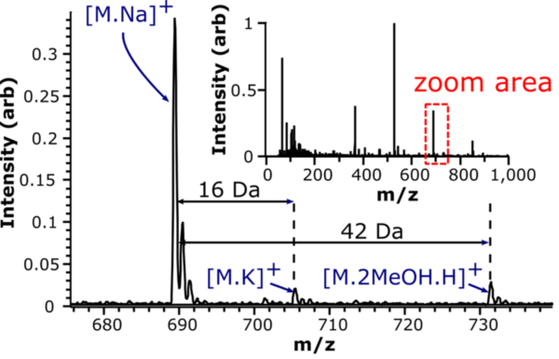

**Fig. 1.** Figure caption; centered.

Every word in a title must be capitalized except for short minor words such as “a”, “an”, “and”, “as”, “at”, “by”, “for”, “from”, “if”, “in”, “into”, “on”, “or”, “of”, “the”, “to”, and “with”. Equations should be centered in the column and numbered sequentially. Place the equation number to the right of the equation within a parenthesis, with right justification within its column. An example would be

$\oint{E∙dL = -\frac{∂}{∂t}\iint{B∙dS}}$ (1)

or

$∇×H=J+\frac{∂D}{∂t}$ (2)

All reference items must be in 8pt font. Number the reference items consecutively in square brackets (e.g., [1]).

References

1. S. M. Metev and V. P. Veiko, *Laser Assisted Microtechnology*, 2nd ed., R. M. Osgood, Jr., Ed. Berlin, Germany: Springer-Verlag, 1998.
2. J. Breckling, Ed., *The Analysis of Directional Time Series: Applications to Wind Speed and Direction*, ser. Lecture Notes in Statistics. Berlin, Germany: Springer, 1989, vol. 61.
3. S. Zhang, C. Zhu, J. K. O. Sin, and P. K. T. Mok, “A novel ultrathin elevated channel low-temperature poly-Si TFT,” *IEEE Electron Device Lett.*, vol. 20, pp. 569–571, Nov. 1999.
4. M. Wegmuller, J. P. von der Weid, P. Oberson, and N. Gisin, “High resolution fiber distributed measurements with coherent OFDR,” in *Proc. ECOC’00*, 2000, paper 11.3.4, p. 109.
5. R. E. Sorace, V. S. Reinhardt, and S. A. Vaughn, “High-speed digital-to-RF converter,” U.S. Patent 5 668 842, Sep. 16, 1997.
6. (2015) The IEEE website. [Online]. Available: http://www.ieee.org/
7. M. Shell. (2015) IEEEtran webpage on CTAN. [Online]. Available: http://www.ctan.org/pkg/ieeetran
8. *FLEXChip Signal Processor (MC68175/D)*, Motorola, 1996.
9. “PDCA12-70 data sheet,” Opto Speed SA, Mezzovico, Switzerland.
10. A. Karnik, “Performance of TCP congestion control with rate feedback: TCP/ABR and rate adaptive TCP/IP,” M. Eng. thesis, Indian Institute of Science, Bangalore, India, Jan. 1999.
11. J. Padhye, V. Firoiu, and D. Towsley, “A stochastic model of TCP Reno congestion avoidance and control,” Univ. of Massachusetts, Amherst, MA, CMPSCI Tech. Rep. 99-02, 1999.
12. *Wireless LAN Medium Access Control (MAC) and Physical Layer (PHY) Specification*, IEEE Std. 802.11, 1997.